Chain of Responsibility
(Behavioural)

The Chain of Responsibility design pattern is a behavioral design pattern that allows an object to pass a request along a chain of handlers. Each handler in the chain decides either to process the request or to pass it along the chain to the next handler.
This pattern encourages loose coupling between sender and receiver, providing freedom in handling the request.

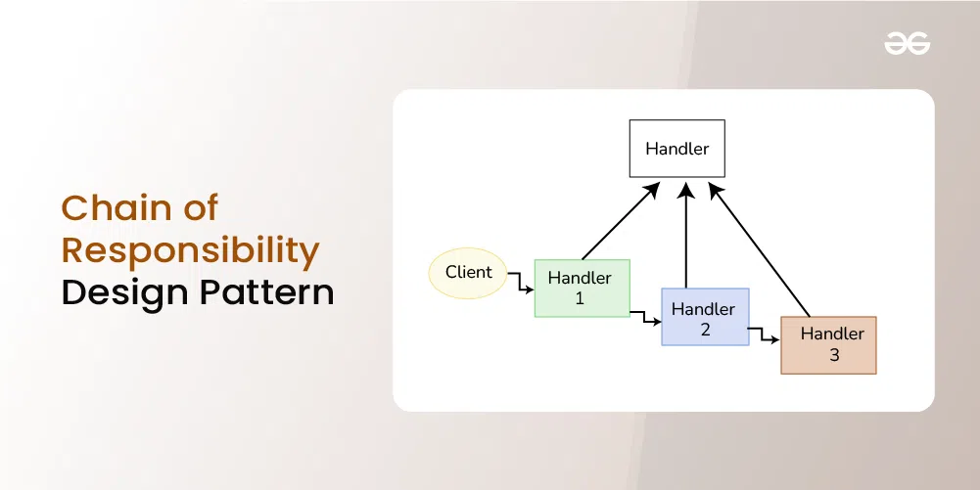

Pros
Below are the pros of chain of responsibility design pattern:
- The pattern makes enables sending a request to a series of possible recipients without having to worry about which object will handle it in the end. This lessens the reliance between items.
- New handlers can be easily added or existing ones can be modified without affecting the client code. This promotes flexibility and extensibility within the system.
- The sequence and order of handling requests can be changed dynamically during runtime, which allows adjustment of the processing logic as per the requirements.
- It simplifies the interaction between the sender and receiver objects, as the sender does not need to know about the processing logic.

Cons
Below are the cons of chain of responsibility design pattern:
- The chain should be implemented correctly otherwise there is a chance that some requests might not get handled at all, which leads to unexpected behavior in the application.
- The request will go through several handlers in the chain if it is lengthy and complicated, which could cause performance overhead. The processing logic of each handler has an effect on the system’s overall performance.
- The fact that the chain has several handlers can make debugging more difficult. Tracking the progression of a request and determining which handler is in charge of handling it can be difficult.
- It may become more difficult to manage and maintain the chain of responsibility if the chain is dynamically modified at runtime.

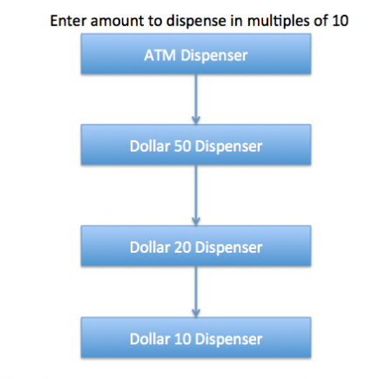

Step 1
public class Currency {

private int amount;

public Currency(int amt){
this.amount=amt;
}

public int getAmount(){
return this.amount;
}
}

Step 2
public interface DispenseChain {

void setNextChain(DispenseChain nextChain);

void dispense(Currency cur);
}

Step 3
public class Dollar50Dispenser implements DispenseChain {

private DispenseChain chain;

@Override
public void setNextChain(DispenseChain nextChain) {
this.chain=nextChain;
}

@Override
public void dispense(Currency cur) {
if(cur.getAmount() >= 50){
int num = cur.getAmount()/50;
int remainder = cur.getAmount() % 50;
System.out.println("Dispensing "+num+" 50$ note");
if(remainder !=0) this.chain.dispense(new Currency(remainder));
}else{
this.chain.dispense(cur);
}
}

}
public class Dollar20Dispenser implements DispenseChain{

private DispenseChain chain;

@Override
public void setNextChain(DispenseChain nextChain) {
this.chain=nextChain;
}

@Override
public void dispense(Currency cur) {
if(cur.getAmount() >= 20){
int num = cur.getAmount()/20;
int remainder = cur.getAmount() % 20;
System.out.println("Dispensing "+num+" 20$ note");
if(remainder !=0) this.chain.dispense(new Currency(remainder));
}else{
this.chain.dispense(cur);
}
}

}

public class Dollar10Dispenser implements DispenseChain {

private DispenseChain chain;

@Override
public void setNextChain(DispenseChain nextChain) {
this.chain=nextChain;
}

@Override
public void dispense(Currency cur) {
if(cur.getAmount() >= 10){
int num = cur.getAmount()/10;
int remainder = cur.getAmount() % 10;
System.out.println("Dispensing "+num+" 10$ note");
if(remainder !=0) this.chain.dispense(new Currency(remainder));
}else{
this.chain.dispense(cur);
}
}

}

Step 4
public class ATMDispenseChain {

private DispenseChain c1;

public ATMDispenseChain() {
// initialize the chain
this.c1 = new Dollar50Dispenser();
DispenseChain c2 = new Dollar20Dispenser();
DispenseChain c3 = new Dollar10Dispenser();

// set the chain of responsibility
c1.setNextChain(c2);
c2.setNextChain(c3);
}

public static void main(String[] args) {
ATMDispenseChain atmDispenser = new ATMDispenseChain();
while (true) {
int amount = 0;
System.out.println("Enter amount to dispense");
Scanner input = new Scanner(System.in);
amount = input.nextInt();
if (amount % 10 != 0) {
System.out.println("Amount should be in multiple of 10s.");
return;
}
// process the request
atmDispenser.c1.dispense(new Currency(amount));
}

}

}

Step 5 (output)
Enter amount to dispense
530
Dispensing 10 50$ note
Dispensing 1 20$ note
Dispensing 1 10$ note
Enter amount to dispense
100
Dispensing 2 50$ note
Enter amount to dispense
120
Dispensing 2 50$ note
Dispensing 1 20$ note
Enter amount to dispense
15
Amount should be in multiple of 10s.
Resources:
https://www.geeksforgeeks.org/chain-responsibility-design-pattern/
https://www.digitalocean.com/community/tutorials/chain-of-responsibility-design-pattern-in-java

